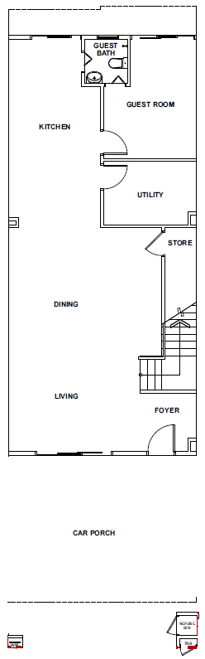
- Add Grille into the sliding door
- Install Water Heater

Add grille into the sliding door
Add Grille into the sliding door
L-Shape kitchen cabinet

Ground Floor
Unit - 318
Type B (Intermediate)

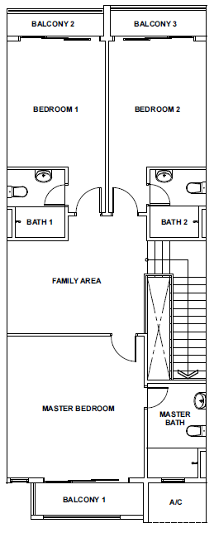
Add grille into the sliding door + windows
Install Aircond
Install Water Heater
1, Add grille into the sliding door

- Add grille into the sliding door

First Floor
Unit - 318
Type B (Intermediate)

